# ASLSC Bronze Camp Check List

**Tasks**

Candidates must register with ASLSC and Life Saving Victoria via the steps below

LSV Course Registration

1. Sign up for Course with LSV via [Member Training from Anywhere](https://mt.lsv.com.au/login)
   1. You must use your SLSA Member Area Account and it must be in the name of the **candidate**
   2. If you do not have an SLSA Member Area account yet because your parents have always renewed your membership as part of a Family Group you will need to create one so that you can enrol in this course. If you are unsure, please contact the Club Office at [info@angleseaslsc.org.au](mailto:info@angleseaslsc.org.au).
2. You can enrol in any of the four courses that are listed for Anglesea (see below)

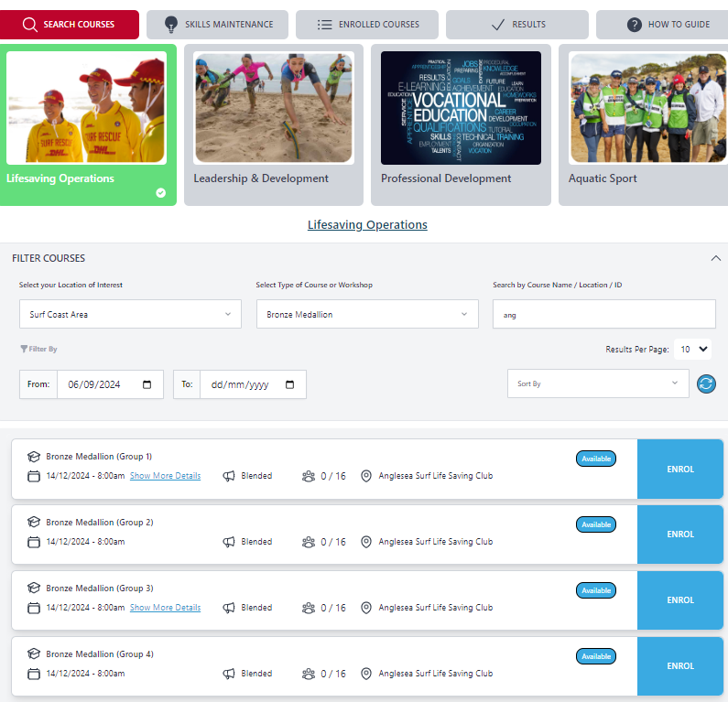

**Pre Course Tasks**

To ensure that you arrive at the camp ready to go there are several activities that you need to complete. Please make sure that both of these activities are undertaken prior to **1st December 2024.**

Practical Tasks

1. 400m Timed Swim Form

* All candidates must be able to swim 400m in 9 minutes
* Download and complete the [Timed Swim Form](https://www.angleseaslsc.org.au/_files/ugd/4e0f4e_4051ed483eec409ba3f62192e65fd33a.pdf)
* Upload Form <https://www.surveymonkey.com/r/PNLJ3DK>
* You will also need to bring this with you to camp

eLearning Tasks & Theory Tasks

Before commencing these tasks candidates should download the PSAR Training Manual

* [Online Version](https://www.manula.com/manuals/slsa/psar/35/en/topic/about)
* [PDF Version](https://clubs.lsv.com.au/cdn/storage/documents/byevbzDGJFPN8Bw8H/original/byevbzDGJFPN8Bw8H.pdf)

1. LSV E-Learning
   1. Log in to [Member Training from Anywhere](https://mt.lsv.com.au/login)
   2. Select Enrolled Courses
   3. Click Show E-Learning
   4. Launch and complete all E-Learning

