

$75.00 family portrait sitting fee (Normally $120.00) plus 10% discount off any portrait orders.

Portrait sitting can be done on location in Anglesea or at our Central Geelong Photography Studio

Corporate headshot special for only $75.00 + G.S.T which members can use for websites Linkedin etc.

Includes high resolution file for print media & a small resolution file for websites.

<https://www.andrewmaudererstudios.com/>

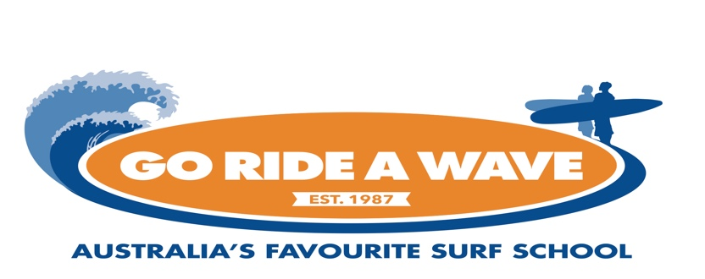

Free Surfboard and wetsuit hire for the rest of the day for any member who does a surf lesson with Go Ride a Wave.

**Membership card/proof of membership must be shown to redeem this deal**

https://gorideawave.com.au/categories/surf-school-location/anglesea-surf-lessons/