ASLSC Nipper/SRC/STarfish Handbook Season 2022/23
Welcome to the Anglesea Surf Life Saving Club (ASLSC or Club) Nipper Summer Program, Surf Rescue Certificate and Starfish Handbook for 2022/23. ASLSC is proud of these programs which provide opportunities for all family members to get involved and develop life-long friendships.
We are excited to say that we will offer the Nipper Summer Program, which will run during the two weeks after Christmas.
In order to operate the Program, it will be critical that:
- We fill all volunteer roles for each age group. If we don’t get enough volunteers in an age group, we may not be able to offer the Program for that group. All age managers need to complete the new online child safeguarding course and age manager proficiency video to complete their new accreditation, which will be valid for the next 5 years;
- Parents and nippers remain flexible, follow instructions, and comply with the Club’s COVIDSafe Guidelines; and
- All parents sign up to the clubs TeamApp as this will be our primary form of communication. Download TeamApp on your smartphone and search for 'Anglesea SLSC'. Complete the registration process and choose 'Nipper/SRC/Starfish Summer Program' as your Access Group. If you are already on TeamApp for ASLSC, go to Membership (white outline of a head) and then add 'Nipper/SRC/Starfish Summer Program' as an additional Access Group.)
- All participants attempt to complete their swim requirements prior to nipper registration. We recognise it will again be difficult this year but having a lifeguard sign off on the relevant swim distance is another necessary step confirmed by LSV this year.
Nipper registrations open 1 October and will close on 1 December.
Please appreciate this is a dynamic situation and modifications may be required and that we are doing everything we can to ensure the nippers have something to look forward to this summer.
This pack provides key information regarding the Nipper / SRC / Starfish Summer Program and Dolphin Surf Sports Program as well as answers to common questions. If you have any further queries, please feel free to speak to us or send an email to info@angleseaslsc.org.au

Patrick Haseler | Shem Fitzgerald | Matilda Cameron | Ivor Morgan | Sam Hume
Big Nipper | SRC Coordinator | Starfish Coordinator | Big Dolphin | Youth Development Director

IndeX of contents

Page 1 | Welcome
Page 3 | Index of Contents
Page 4 | Key Dates
Page 5 | Beach Set Up
Page 6 | Program Overview
Page 6 | Frequently Asked Questions inc SRC and Starfish (page 10)
Page 13 | Costs
Page 14 | Dolphin Surf Sports Program
Page 15 | Nipper Carnival Dates
Page 16 | Competition Pack

Key Dates
Key dates are subject to change and are not yet confirmed.
NIPPER SUMMER PROGRAM & DOLPHINS DATES 2022/23
DATE | DAY | NIPPERS | SRC | DOLPHINS
26 December | Monday | Sign in and bag collection, age managers session
27 December | Tuesday | Session 1 | Session 1 (9am-12pm) | Club Training  Roo Run
28 December | Wednesday | Club swim (Rock to Ramp), lawn bowls night
29 December | Thursday | Session 2 | Session 2 (9am-12pm) | Club Training
30 December | Friday | Session 3, Doorknock | Session 3 (9am-12pm)
31 December | Saturday
1 January | Sunday
2 January | Monday | Session 4 | Session 4 (9am-12pm)
3 January | Tuesday | Session 5 | Session 5 (9am-12pm) | Club Training
4 January | Wednesday | Session 6, Club Champs, Family Night
5 January | Thursday |  |  | Club Training
6 January | Friday | Session 7 – Junior Carnival | Exam? (8am-2.30pm)
7 January | Saturday | Session 8 (Club champs back up)
8 January | Sunday |  |  | Club Training
9 January

age groups
The Nipper Summer Program is tailored to your child’s age group. The age groups designated by Lifesaving Victoria (LSV) for the 2022/23 season (determined by age at midnight on 30 September 2022) are outlined below.
Age as on 30 September | Age group | Awards
6yo+ (1 Oct 2014 and earlier) | Starfish | N/A
6yo (1 Oct 2015 – 30 Sept 2016) | Under 7s | Surf Play 2
7yo (1 Oct 2014 – 30 Sept 2015) | Under 8s | Surf Aware 1
8yo (1 Oct 2013 – 30 Sept 2014) | Under 9s | Surf Aware 2
9yo (1 Oct 2012 – 30 Sept 2013) | Under 10s | Surf Safe 1
10yo (1 Oct 2011 – 30 Sept 2012) | Under 11s | Surf Safe 2
11yo (1 Oct 2010 – 30 Sept 2011) | Under 12s | Surf Smart 1
12yo (1 Oct 2009 – 30 Sept 2010) | Under 13s | Surf Smart 2
13yo (1 Oct 2008 – 30 Sept 2009) | Under 14s | Surf Rescue Certificate

Beach Set Up

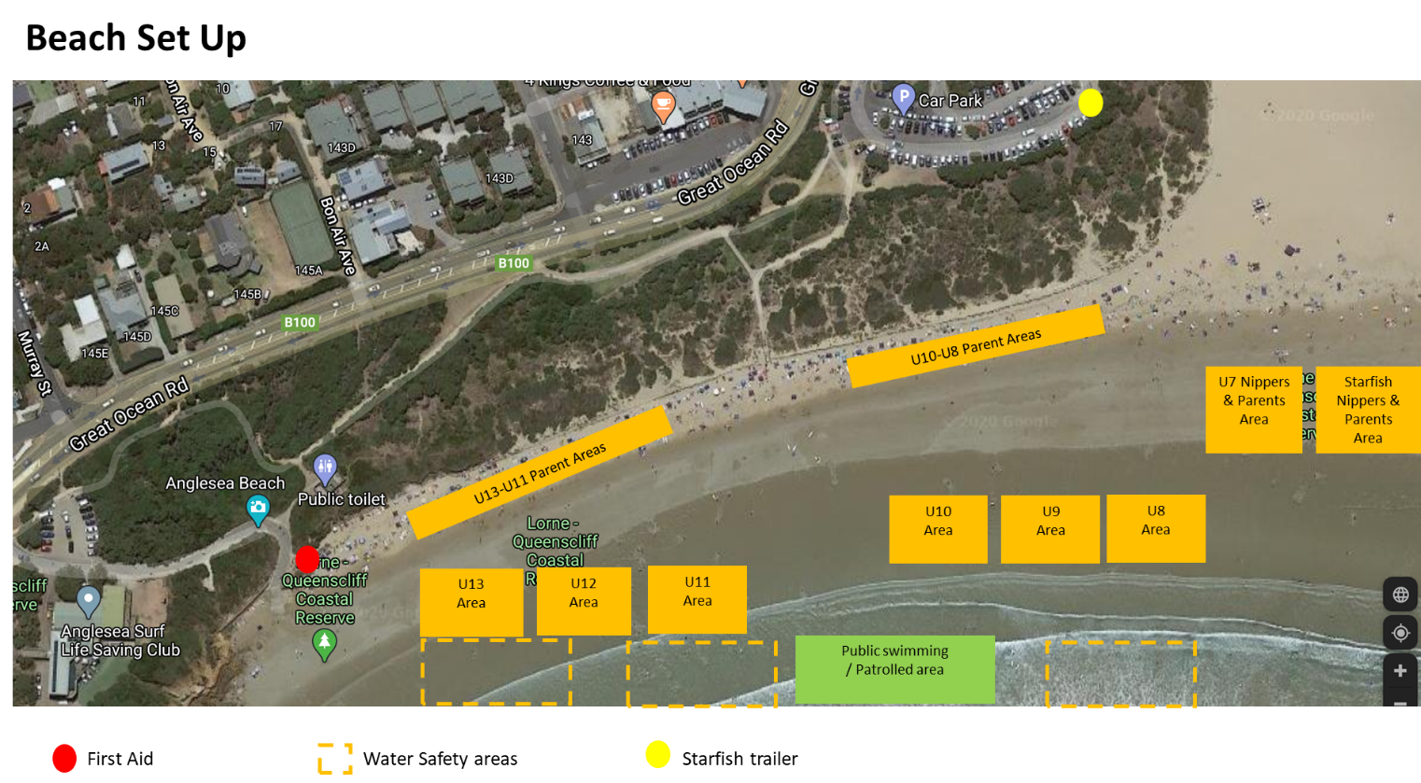

Nipper summer program overview
The Nipper Summer Program is a 7-9 session program over summer which gives all children the opportunity to participate, learn and have fun.
The program focuses on:
- Fun
- Basic first aid
- Awareness of beach hazards such as rips, waves, rocks etc.
- An introduction to aspects of surf sport activities such as board paddling, wading, beach flags etc
Each age group has certain skills and activities to learn and in turn each child receives a certificate. Each nipper is required to have achieved all the skills of their age group to be awarded the relevant certificate. Certificates will be presented at the conclusion of the program where awards for age group champions will also be presented from the club championship day.
Nippers can be members of multiple surf lifesaving clubs but are ineligible to become age group champions if they do not compete for ASLSC at local and state championship carnivals.

requirements prior to registration for nippers and src
Before registration for nippers and SRC, you will need to complete one of the following assessments and upload the signed form at the time of enrolment. Accredited swim teachers and swim coaches can complete this assessment.
The NEW Junior Preliminary Assessment Template for POOL Assessments can be accessed here
The NEW Junior Preliminary Assessment Template for Open Water Assessments can be accessed here

CATERING
The catering arrangements will be finalised closer to Christmas, but at this point (October 2022), there is will be a number of post session BBQs during the Nipper Summer Program.

Frequently Asked questions

Does it matter that my child hasn’t been at Nippers since under 7s?
No. Each child will be taught what is required for their particular age group. The Nipper Summer Program is open to all children regardless of their previous experience.

What will my child learn?
Each age group has a series of skills and information they will be taught over the 9 sessions consistent with the age appropriate LSV award relevant to their age group.

Does the Nipper Summer Program teach my child to swim?
No. The Nipper Summer Program is not a “learn to swim” program and we strongly advise that you enrol your child into swimming lessons. Please advise your child’s age group manager (Age Manager) if your child is not a competent swimmer. There are strict minimum requirements for this program that your child must be able to complete.

Who are the Age Managers?
The Age Managers are members of the Club who are often parents of a child in that age group and have been through the Nipper Program themselves. They have completed an induction course which equips them for the role, and they have agreed to volunteer their time to assist the Club and support the nippers and the nipper program. They require parent volunteers to assist them, and we encourage all parents whose children are participating in the Nipper Program to make themselves available to help on the beach. Water safety officers are also vital to the program and, alongside the Age Managers, are a great example of the leadership, mentoring and team spirit within our Club.

What do I need to bring to the Nippers Summer Program sessions?
We recommend you bring a bag to enable your child to deal with the variety of conditions that may be experienced on the beach.
Your nipper will be provided with a welcome pack on at nipper induction/gear pick-up that will include:
- a pink rash vest;
- a t-shirt;
- and if new to ASLSC nippers, a bucket hat and an ASLSC cap
We suggest you name these items as soon as possible. Writing your child’s name on their cap so it can be read by Age Managers and water safety officers is also extremely helpful. These items must be worn during all sessions. Other essential items that you will need are:
- bathers;
- towel;
- goggles;
- sunscreen (applied before and during the session);
- water bottle; and
- warm/dry clothes suitable for the weather.
We also advise nippers to bring a wetsuit as even on warm days, Victorian wind and waters can be cold.

What is an S badge (Competition skills evaluation) and how does my child get one?
LSV requires that nippers who want to participate in Junior Carnivals meet the minimum swimming requirements for their age group (Competition Skills Evaluation or S badge).
A Competition Skills Evaluation / S-badge is NOT required to participate in our Nipper Summer Program. It is only required for those nippers wanting to compete in the water-based carnival events or join the Dolphin Surf Sports Program. Nippers can gain their S badge during a Dolphin Surf Sports Training session or during the Nipper Summer Program. They must confidently complete a continuous freestyle swim over the relevant distance listed below.
We will not give out an S badge unless we are absolutely sure the nipper can confidently swim the required distance.
Age groups | Distance
Under 7s & 8s | No S badge
Under 9s | 150m swim in 12 minutes
Under 10s | 150m swim in 11 minutes
Under 11s | 288m swim in 12 minutes
Under 12s | 288m swim in 10 minutes
Under 13s | 288m swim in 9 minutes

My child has enjoyed the Nipper Summer Program so much they would like to learn more and start training. How does this work?
We welcome all nippers to our surf sports program called Dolphins. If a nipper would like to continue on and start competing for our Club all you need to do is contact the Big Dolphin (Dolphin head coach and coordinator). While there is no additional cost for participating in the Dolphin program, additional costs will be incurred where nippers compete in carnivals to cover entry costs.

Does my child need to undertake all activities?
No. While activities are tailored to the relevant age groups and Age Managers / coaches are available for support, nippers can opt out of activities which they are not confident of undertaking.

Is there a uniform?
The ASLSC shop stocks an extensive variety of Club clothing. It is located at the clubhouse.
During the Nipper Summer Program, all nippers must wear an Anglesea nipper cap (provided to new nippers but available for purchase if lost) during all sessions and a fluorescent rash vest is required to be worn in the water so they are easily identifiable during water training by coaches, Age Managers and water safety officers.
ASLSC is a SUN SMART CLUB. All nippers are strongly encouraged to wear a broad brimmed hat, sunscreen and rash vest. Wetsuits are not compulsory but are advisable in Victorian waters.
For carnivals, a club nipper cap is compulsory, and children must marshal with a wide brimmed hat and t-shirt covering their shoulders.

How do I know my child will be safe at Nippers?
ASLSC provides a number of protection measures to ensure your child is safe at all times including the following items:
- All members involved with nippers who are over 18yo are required to have a Working with Children Check.
- A Life Saving Victoria endorsed water safety check list and risk assessment is filled out prior to every session.
- All Age Managers have completed an induction course which equips them for the role, and in 2023 there are new LSV requirements with an Age Manager Online Course to complete prior to the program.
- The number of water safety officers prescribed by LSV will be in the water with the nippers at all times.
- A first aid officer is available at each session as well as at carnivals.
- A first aid kit is at every session and carnival.
- If conditions are precarious, the program will be adjusted accordingly.
- A Member Protection Officer is available for all club members.
Our programs are not a babysitting service. One (but no more) responsible adult MUST be present at all times for each session. If a child is ill or injured, we will utilise our first aid officer and potentially return the child to their parent. Taking an Age Manager, coach or water safety officer off the beach to oversee a child’s care (in the absence of their parent) potentially leaves the other children in the program under-supervised and at risk. If you are called away in an emergency, you MUST notify the Nipper Summer Program Coordinator or the Dolphin Surf Sports Coordinator and leave a mobile number and expected return time or alternative arrangements for the care of your child.

Can I borrow equipment from the Club?
Members of the ASLSC can borrow equipment (mostly nipper boards) and need to ensure any borrowed boards are washed and personally returned to the clubhouse. If boards are left on the beach at the end of the day, this privilege will subsequently be removed. Please see the Big Dolphin (Dolphin Surf Sports Coordinator) for more information.

What can I do as a parent?
Most of the people who make Nippers happen each year are parent volunteers. Age Managers set the agenda and plan for each session, but the process works best when additional helpers can assist with other roles. We will need assistance with Age Manager / Leader, water safety, coaching, first aid, equipment managers (for set up, pack up & cleaning) and age group COVIDSafe officers. It would be appreciated if parents willing to assist could make themselves known through the online registration process. This is a great chance to get involved in your child’s activities regardless of your surf lifesaving experience. Alternatively, please contact info@angleseaslsc.org.au if you would like to contribute and we will be in touch. If you ticked a box during the sign-up period indicating you were willing to help a member from our Youth Team will be in touch with you.

What happens to images taken of the nippers?
By becoming a member of ASLSC you consent to the Club using your name, image, likeness, and performance in any SLS activity at any time to promote the Club, by any form of media.

What are the club championships?
Nippers have the opportunity to compete in a low key, age-appropriate and fun carnival during one session of the Nipper Summer Program. This is a great introduction to surf sports, and the emphasis is on participation and having fun. Ribbons are awarded and an overall male and female age group club champion is awarded. Please note that to be eligible to be age group club champion, a nipper must have their competition rights with Anglesea SLSC (that is, not compete for an alternative club in local and state championship carnivals). The club championships also serve as a selection event for teams and individual events at the Victorian Surf Life Saving Championships – see the document Junior Surf Sport | Team Selection Policy which is available in the documents section of TeamApp.

How do I find out what is happening around the Club?
There are many ways to find out about Club news:
- A Line in the Sand email: Weekly email on Friday updating all members of the club on current activities and important information.
- Via Text Message or email: The Club will send an SMS to specific groups with urgent or important information. Please ensure the Club has a relevant Mobile Phone Number and email for you.
- TeamApp Nipper Updates – Download TeamApp™ on your smartphone and search for “Anglesea SLSC”. Complete the registration process and choose “Nipper/SRC/Starfish Summer Program” as your Access Group. If you are already on TeamApp for ASLSC, go to Membership (white outline of a head) and then add “Nipper/SRC/Starfish Summer Program” as an additional Access Group.
- Dolphin Surf Sports Coordinator updates: Those involved in the Dolphin Surf Sports Program must join TeamApp and select “Anglesea SLSC” and “Junior Competition Team Members” for regular news and information from the Dolphin Coordinators to ensure you have all the up to date information you need to be part of this program.
- The Website: https://www.angleseaslsc.org.au
- Social Media: Facebook Anglesea SLSC & Instagram @aslsc
- Nipper Summer Program: The first 10 minutes of every Nipper Summer Program session is used to share information and to give important announcements. Please try and be available for this time.

What happens after Nippers?
There are many opportunities for young people to move into the youth and senior areas of the Club.
- Gain the Surf Rescue Certificate (see below), a First Aid Certificate and Bronze Medallion
- Patrol Anglesea beach and potentially become a professional lifeguard over summer
- Compete in senior (U14, U15, U17, U19 and Open) carnivals
- Specialise in areas of competition at a State or National Level
- Become involved in many leadership and personal development programs through Life Saving Victoria and locally including becoming a Nipper Age Manager
Speak to our Youth Development Director Sam Hume for more information about life after Nippers.

ABOUT THE SURF RESCUE CERTIFICATE (SRC)
https://sls.com.au/role/surf-rescue-certificate/
The Surf Rescue Certificate provides participants with the skills and knowledge of basic patrolling and surf awareness to be able to participate in lifesaving operations and act in the role of Water Safety Personnel.
What qualifications and/or prerequisites do I need?
To undertake this role there are no specific qualifications or prerequisites other than being able to swim 200m in under 5 minutes in a pool of at least 25m in length, or over a measured open water course, prior to undertaking any water training or assessment activities. You must be at least 13 years of age on the date of final assessment.

Starfish NIPPERS
Starfish Nippers is a lifesaving skills program designed for children and young adults with a disability 6 years and older. The program aims to improve young people with disabilities beach safety and water awareness skills.
Originally started by volunteers at Anglesea SLSC, the Starfish Nipper program is now being run at lifesaving clubs around Australia and overseas. The program caters for participants with numerous disabilities including Autism, Asperger’s, and Down Syndrome.
Our Starfish group is an integral part of our Summer Program at Anglesea SLSC and meaningful inclusion is one of our key objectives; therefore, our Nipper age groups and Starfish group often team up and work together to achieve their goal of improving water awareness skills.

Who organises the Nipper summer and Dolphins Program?
Role | Name | Contact Details
Youth Development Director | Sam Hume | youthdevelopment@angleseaslsc.org.au
Big Nipper / Summer Program | Patrick Haseler | patrickhaseler@hotmail.com
Dolphin Surf Sports | Ivor Morgan | ivor@jimsstorage.com.au
Surf Rescue Certificate | Shem Fitzgerald | ShemF@ggs.vic.edu.au
Starfish Nippers | Matilda Cameron  Naomi Symington | matildacameron96@gmail.com  naisymington@gmail.com
Administration Coordinator | Jennie Mauderer | 5263 1107 info@angleseaslsc.org.au www.angleseaslsc.org.au
We hope you enjoy your experience with our Club. If you have any other questions, please contact one of the people above.

Costs

What does Nippers cost?
The Nipper Summer Program includes:
- membership to the ASLSC for two parents and a nipper;
- a “Nipper Pack” – rash vest, long sleeved t-shirt, and for new members, nipper cap and bucket hat;
- S badge (Competition Skills Evaluation) testing if participating in the Dolphins Surf Sports Program; and
- Life Saving Victoria awards for each age group (upon successful completion of requirements).

ASLSC Membership Fee
Family – 1 or 2 Adults & 1 Child $260
Each additional Nipper $70
Family (Health Care Card Holder) $200
Each additional Nipper (Health Care Card) $45
Nipper levy (per nipper) $25

Additional Costs to the Nipper Summer Program:
Surf Rescue Certificate (SRC) for U14 Nippers $50 (payable with registration)
Local Carnival Entry Fee (LSV entry cost price) $35
Victorian Championships (LSV entry cost price) $55
Competition Pack (not available 2022/23) $*

*3 local carnivals, state titles entries plus jumper, bag, deck coat/jacket in 1st, 2nd and 3rd year competing respectively

Parents must have a Working with Children Check (Volunteer) for the safety of all our Nippers.

DOLPHIN SURF SPORTS PROGRAM
The Dolphin Surf Sports Program is a year-round program where nippers and youth train regularly and are able to compete in various events at Victorian carnivals organised by Life Saving Victoria throughout the season (usually December to March). Dolphins attend Club Training Days which run throughout the year, monthly over the off-season and then weekly from November until the Victorian Junior Lifesaving Championships in February/March.
All nippers are welcome to join our Dolphin Surf Sports Program if they have participated in the Nipper Summer Program and have achieved their age group swimming (S badge) distances (note U8 do not require an S-Badge).

How does my child get involved in the Dolphin Surf Sports Program?
Nippers who are able to swim their age group S badge distance are eligible to join the Dolphin Surf Sports Program. Dolphins coaches work with the nippers on skill development and fitness in an enjoyable and fun setting. Many Dolphins like to go on to compete at carnivals, but it is not compulsory to do this.
The timing and location of sessions are available on TeamApp by following the Access Group “Junior/Nipper Competition Team Members”. A December training weekend and June Queen’s Birthday long weekend adventure race are additional social and team building activities which unfortunately have been deferred due to the COVID pandemic.

Does the Dolphin Surf Sports Program teach my child to swim?
No. Your child must have their current S badge (or previous year’s S badge if it is before S badge testing) or be able to show the coaches they can swim the S badge distance for their age group (no S-Badge needed for U8).

What does my child need to bring to DOLPHIN training?
Dolphins need to be ready for a variety of training opportunities. Coaches ask that at each session they arrive in running shoes, shorts, t- shirt and bring:
- a drink bottle;
- bathers;
- towel;
- goggles;
- fluoro/high visibility rash vest; and
- sunscreen.
Wetsuits and swim caps are optional, but highly advisable.

What events can they compete in?
There are many events offered at carnivals both individual and team. Teams are made up by the team manager before the carnival day and competitors can choose which individual event they go in on the day. There are events which include the disciplines of swim, iron, board, wade, sprint, run and flags. For U12s, U13s and U14s there is also the belt and reel and board rescue events. Teams are made up of 4 nippers, apart from board relay which is a team of 3.
Note there are no swim events for U8s (and no need for an S-Badge).

How do I register for carnivals and HOW MUCH DOES it cost?
Each Nipper who wishes to compete at a carnival must have their S-Badge (unless U8 where no S-Badge is needed). To be entered into a carnival each Nipper must pay and register via the link on the Youth & Nippers webpage by 12pm on the Friday 8-9 days before the carnival. Once LSV close entries we cannot enter late entries. Competitors cannot turn up to a carnival without having been entered by our admin staff.

COMPETING FOR ASLSC
Our Competition Team is a great group of young people of varying abilities who enjoy having fun in the surf, challenging themselves physically and mentally and representing our club. We offer training monthly over the off-season and every Sunday at 10am from November to March.
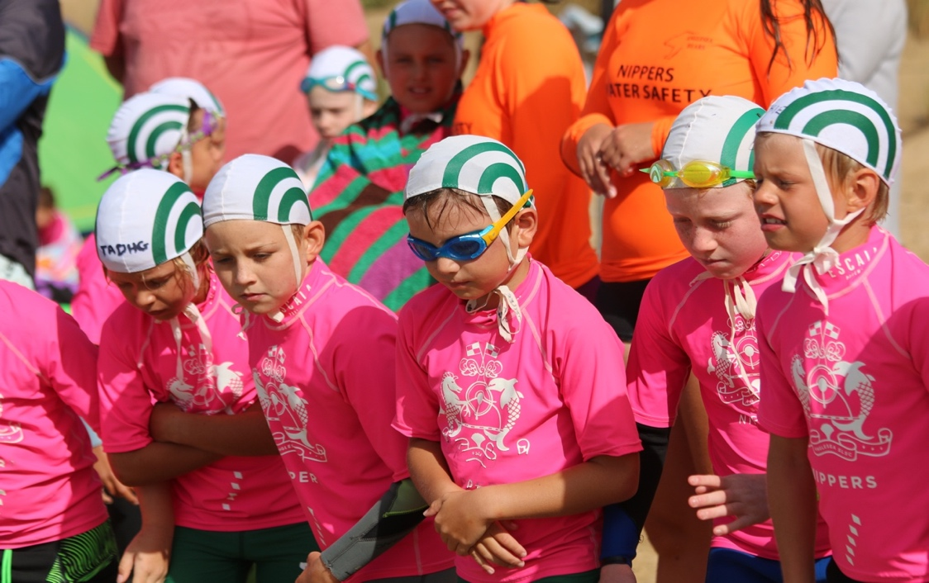

Nipper Carnivals
The Nipper Carnivals begin with the Endurance Championships scheduled for 22 October 2022. Endurance Championships are a one-off carnival and combined with seniors for U12 and U13 only.

For the regular 2022/23 season there are five main carnivals scheduled to be held in Mt. Martha, Ocean Grove, Cosy Corner, Mordialloc and Point Leo between November 21st and finishing with Victorian Junior Life Saving Championships in Warrnambool early March 2023. Carnivals are usually for U8-U13 age groups and there are no carnival events for the U6 and U7 age groups. The Victorian Junior Live Saving Championships are for U9-U13 age groups only.
LSV does have contingencies for all events for extreme weather and other deleterious conditions, and the practicalities of the ocean-based events means these are usually announced at late notice. Note these dates/venues are subject to change.
Saturday 22 October 2022 | Cosy Corner | Endurance Championships
Sunday 6 November | Anglesea 10am | Club Training Day
Saturday 12 November | South Melbourne | Beach Carnival (U12-Open)
Sunday 13 November | Anglesea 10am | Club Training Day
Sunday 20 November | Anglesea 10am | Club Training Day
Sunday 27 November | Anglesea 10am | Club Training Day
Saturday 3 December | Ocean Grove | Nipper Carnival
Sunday 4 December | Anglesea 10am | Club Training Day
Sunday 11 December | Anglesea 10am | Club Training Day
Sunday 18 December | Anglesea 10am | Club Training Day
Friday 6 January 2023 | Cosy Corner Carnival | Nipper Carnival
Sunday 8 January | Torquay | Summer Surf Series #2 (Jim Wall)
Sunday 29 January | Bayside Carnival | Nipper Carnival
Sunday 5 February | Eastern Carnival | Nipper Carnival
Sunday 12 February | Lorne | Senior Carnival #3 (&U13/Masters?)
Sunday 19 February | Surf Coast | Nipper Carnival
Friday 10 March | Warrnambool | Nipper State Titles
Saturday 11 March
Sunday 12 March
Saturday 25 March to Sunday 2 April | Western Australia | Australian Titles (inc U13)

Any questions regarding competition can be directed to the Club office info@angleseaslsc.org.au

Carnival entry was $35 per carnival and $55 for State Championships for 2022/23. Entries can be done on an event-by-event basis via the online portal. You can follow the link below for more information.
https://www.angleseaslsc.org.au/nippers

COMPETITION PACK (not available 2022/23)
If you want to do three or more carnivals, sign up for our Competition Pack for $130 (awaiting confirmation 2021/22) through the online registration. We will encourage attendance at the three carnivals (in GREEN above) and State Championships as part of the competition pack (although we can transfer any entry to another carnival as part of the competition pack if individual circumstances arise and we receive notice well ahead of time).
The Competition Pack seeks to recognise those nippers who make a commitment to represent the club at three or more carnivals each year. In the athlete’s first three years, they also receive a piece of competition team gear:
Year 1 – Competition Team Jumper
Year 2 – Competition Team Bag
Year 3 – Competition Team Deck Coat

If you need any further information or assistance, please contact Ivor Morgan at ivor@jimsstorage.com.au
A condition of competition is that a parent or older sibling is available for a half day's duty at each carnival and one day at State Titles (water safety, LSV set up, LSV pack up, official). These club requirements are set by LSV based on our competitor numbers and we endeavour to meet them through pro rata contributions of each competitor’s families. One qualified person is needed for every three competitors and LSV inform us that again in 2022/23, there will be strict enforcement of this ratio.
We are excited to welcome all families into the Anglesea Nipper family and hope you all enjoy your time in the club.
The following people made significant contributions to the development and revision of this handbook

Sam Hume
Patrick Haseler
Raylene Fordham
Yvette Morgan
Ivor Morgan
Naantali Marshall
Shem Fitzgerald
Matilda Cameron
Jennie Mauderer

